In this lab, we will understand the data refinery part by using the same data asset which we have used earlier in the data governance lab.

Under the asset section, Click and open the data asset

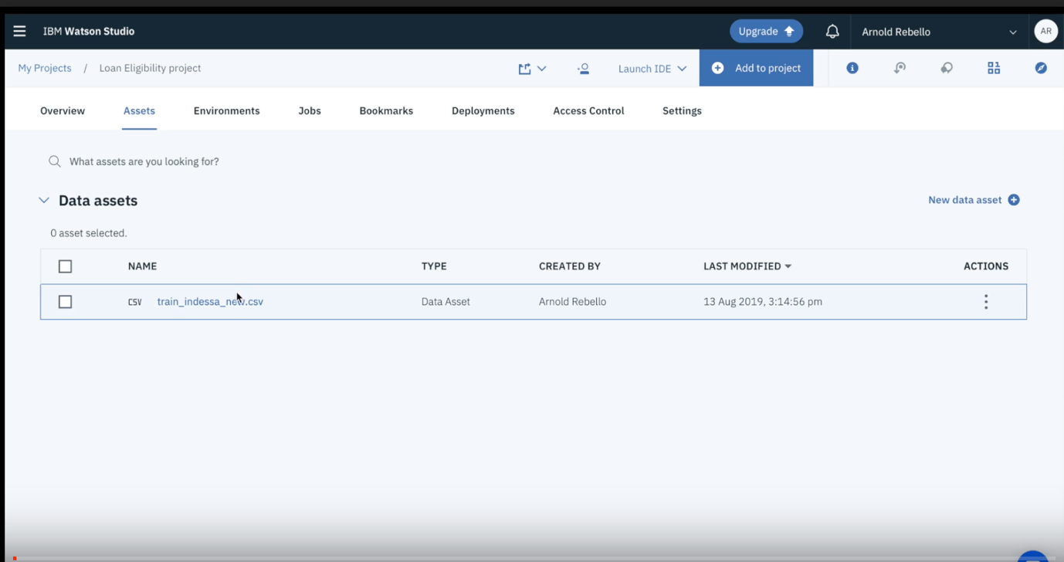

Click on “Refine” as shown below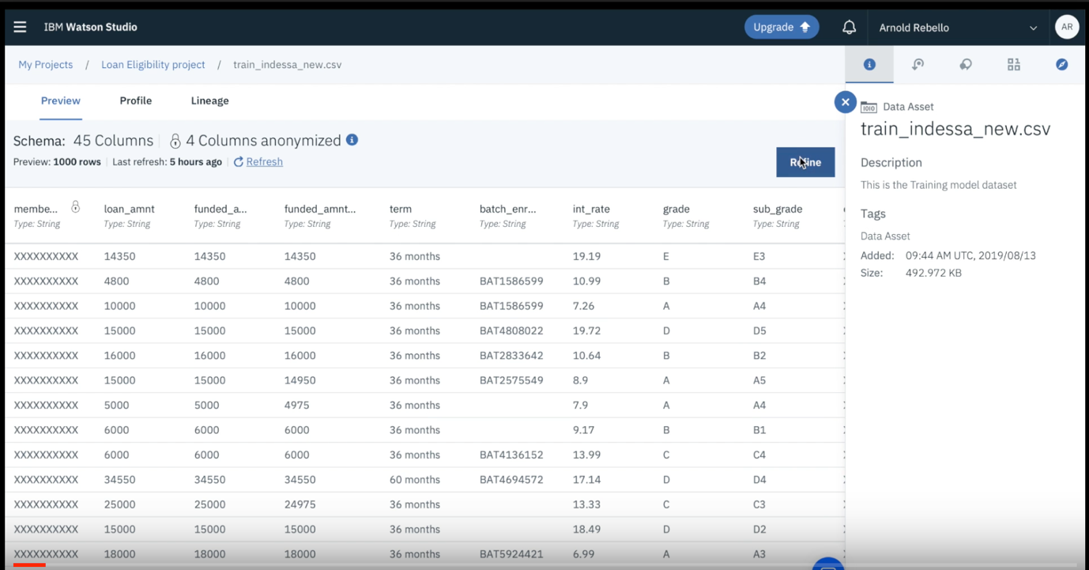

Select “+ operations”

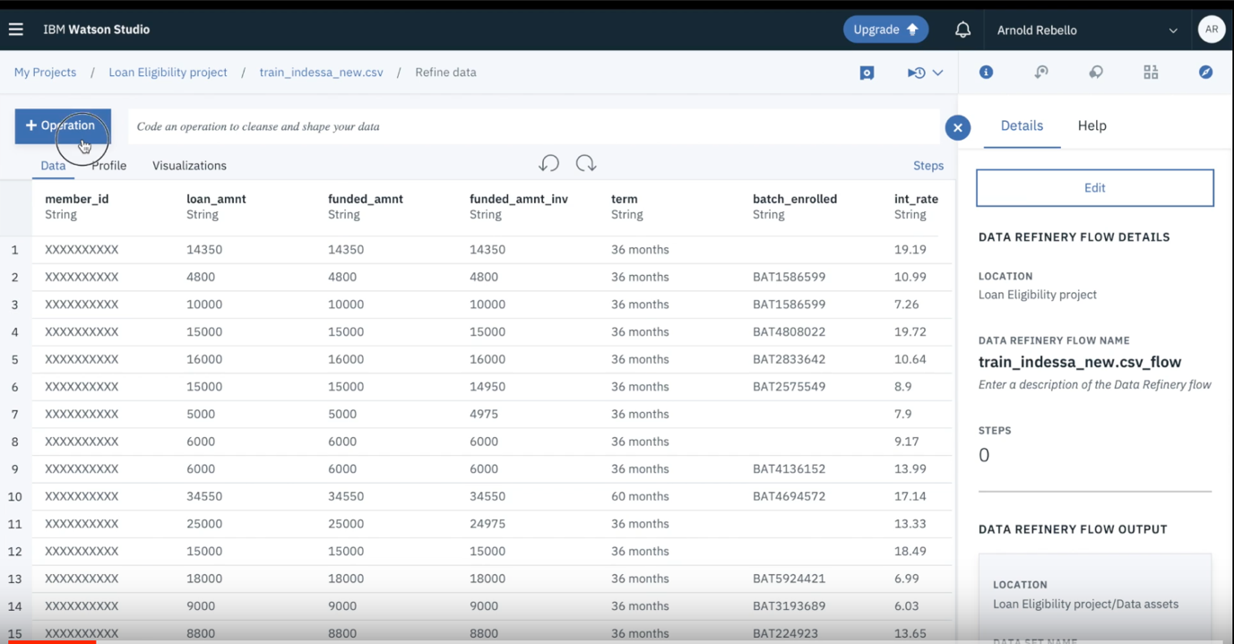

Click on remove

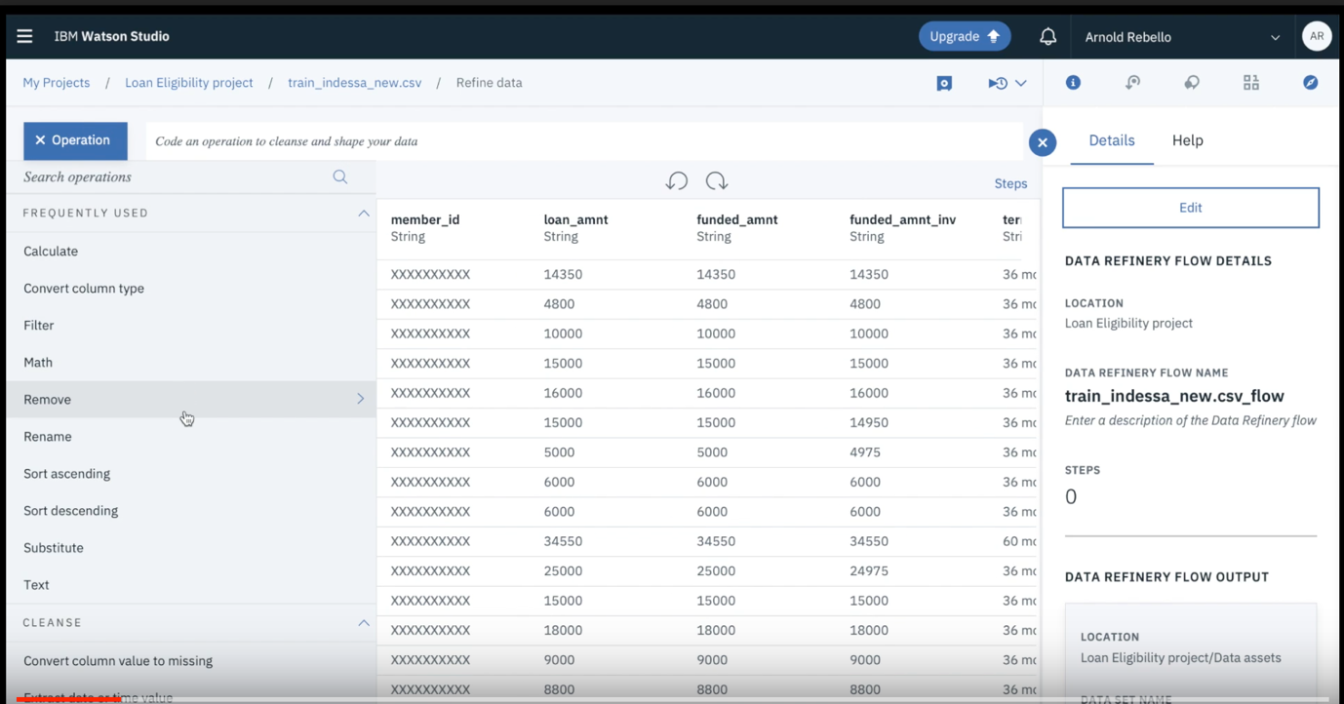

Type desc and click on next to remove the desc column

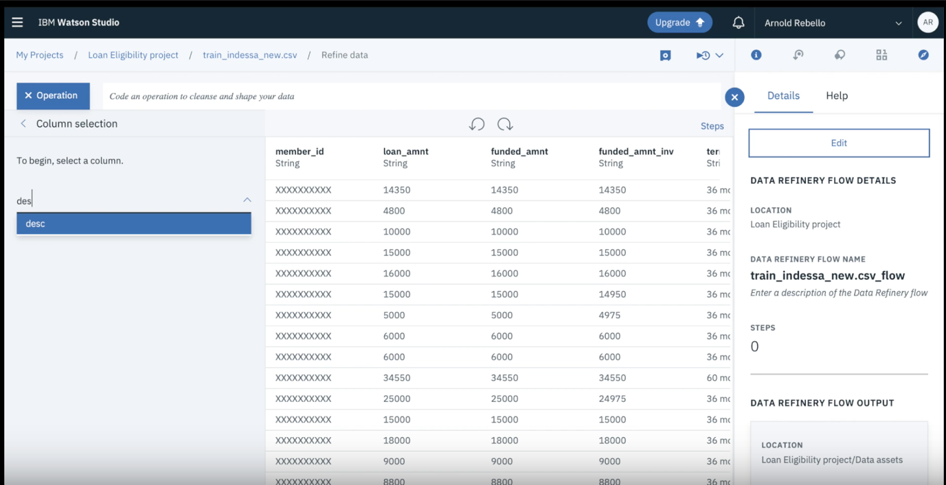

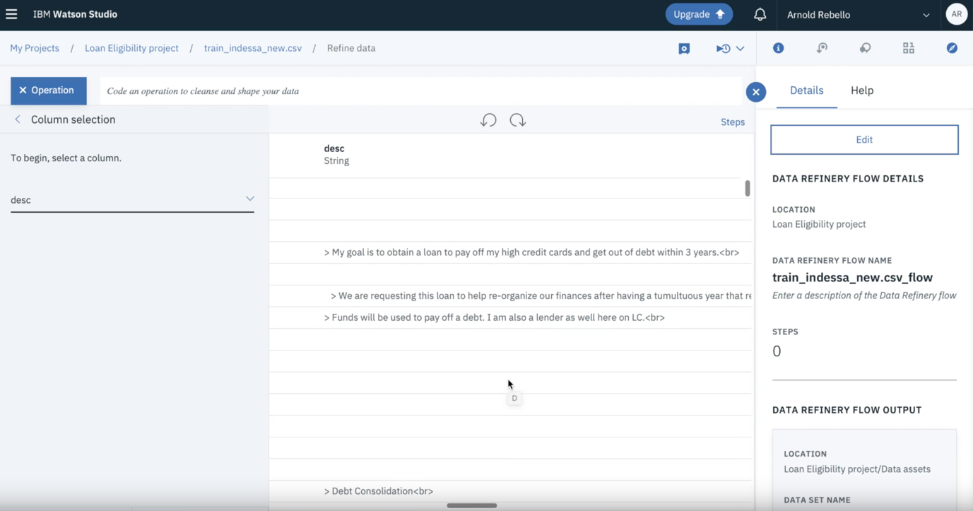

Again Select Operation and choose “replace substring”

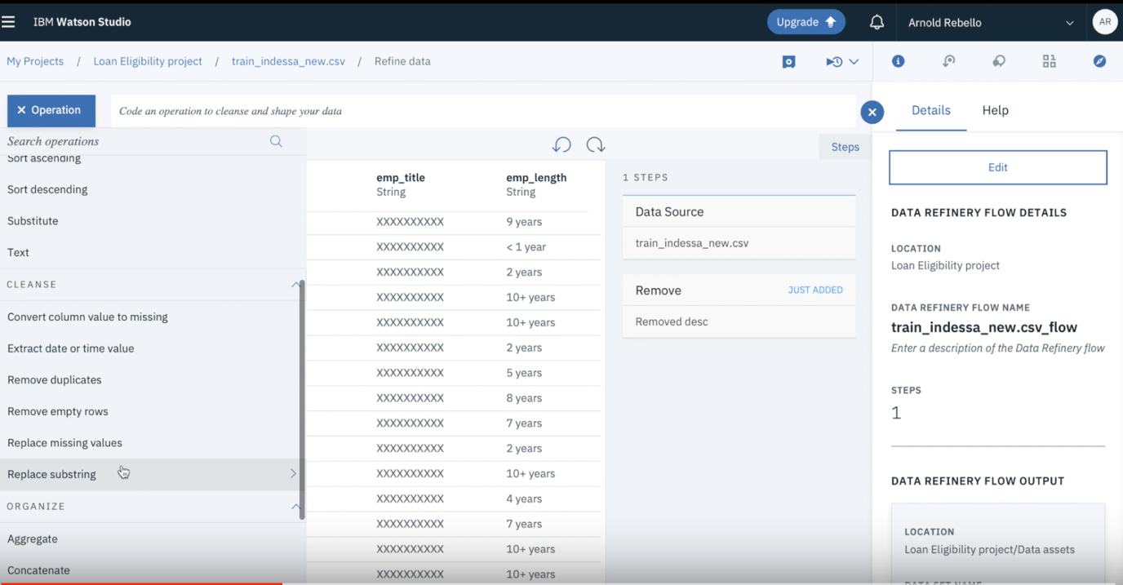

Under the column selection Tab, Select emp_length

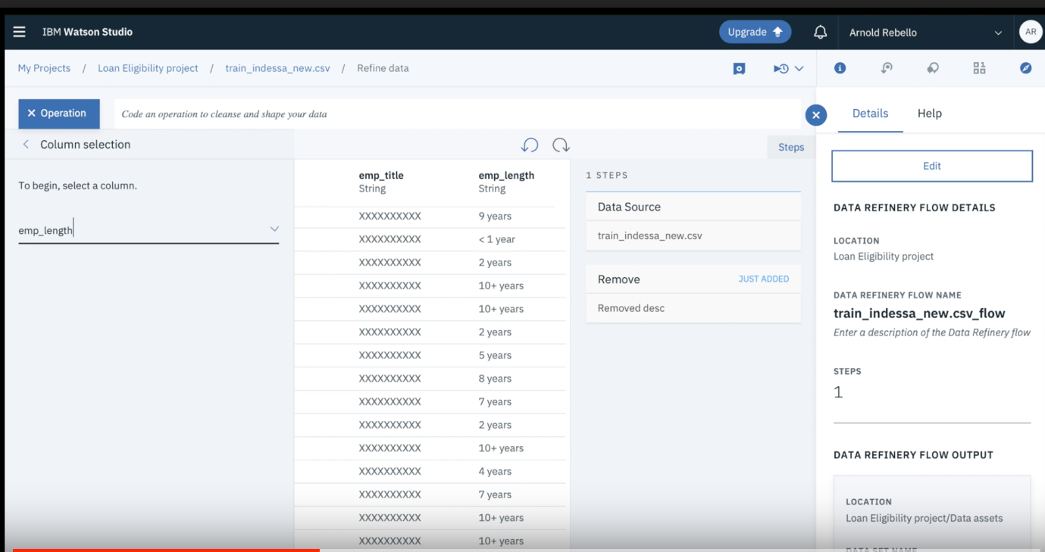

Select text add the choose/Type the value as <1 year and replace it by 1 as shown below

Click next

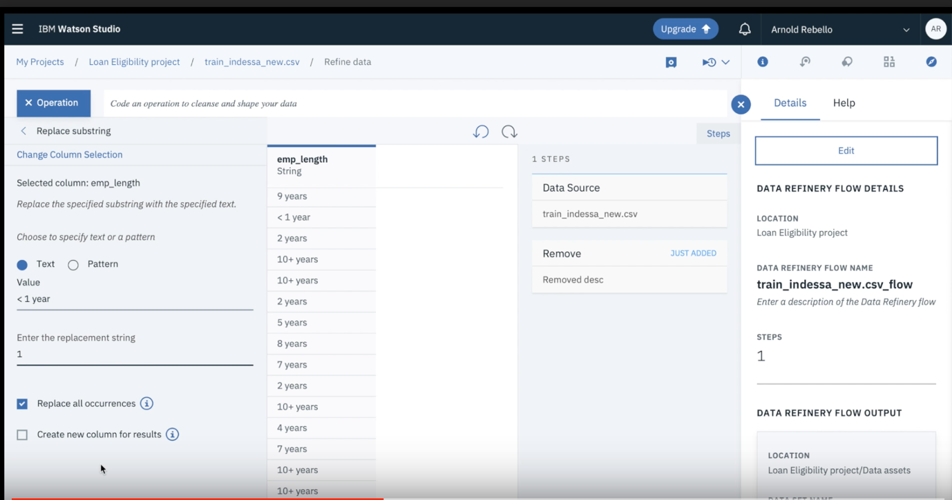

Repeat the same steps to change/replace 10+ years with 11 and observe the changes in the data asset.

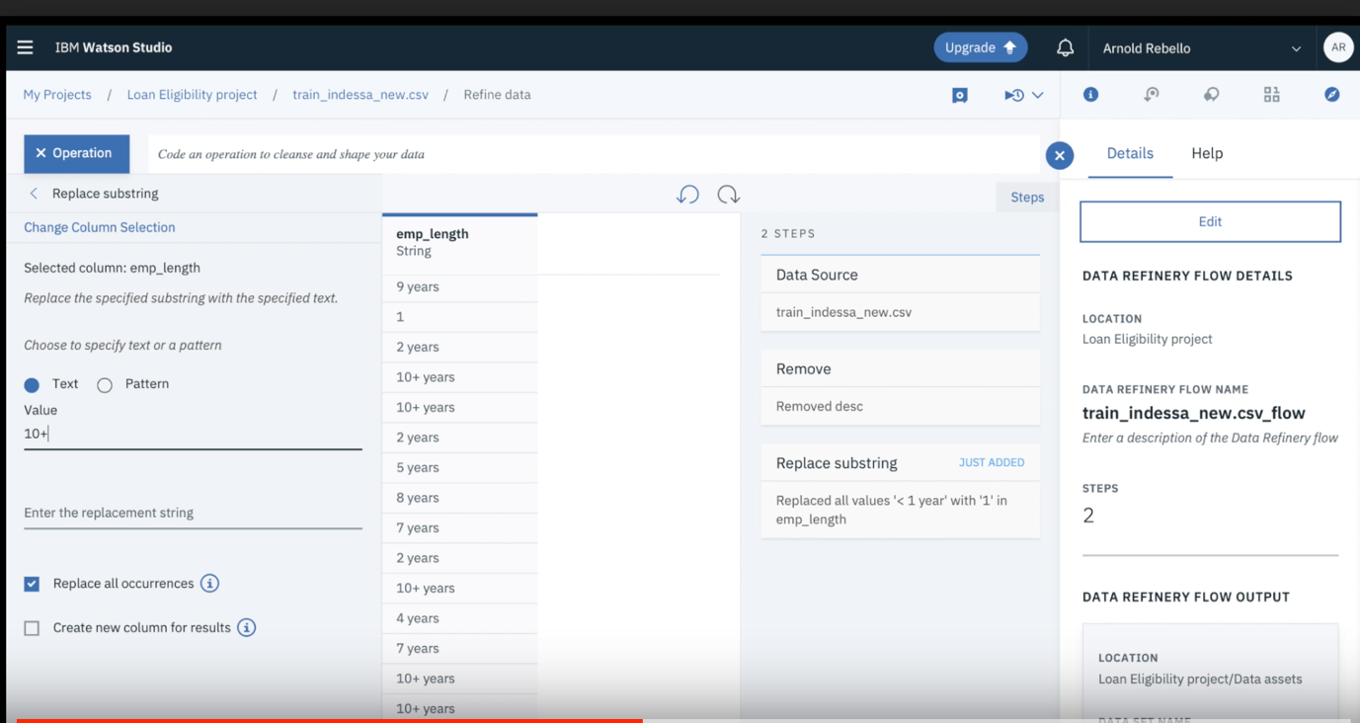

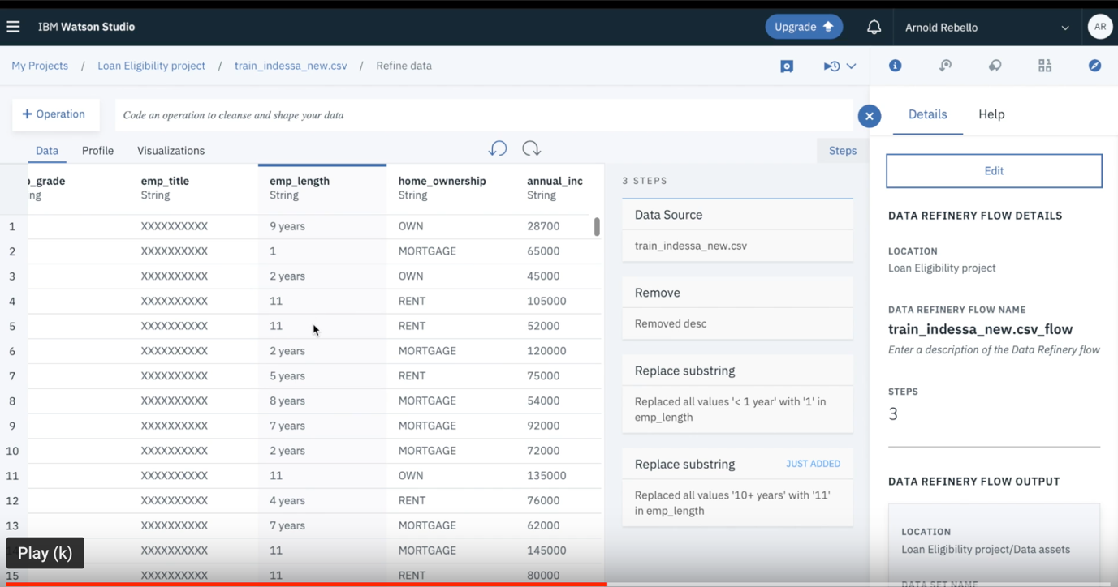

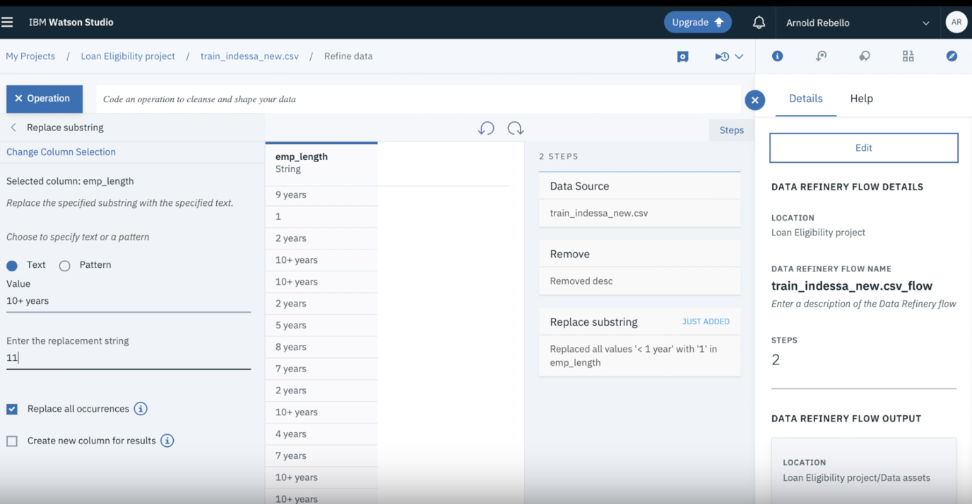

Similarly, we can select a column and change the name of column as shown below

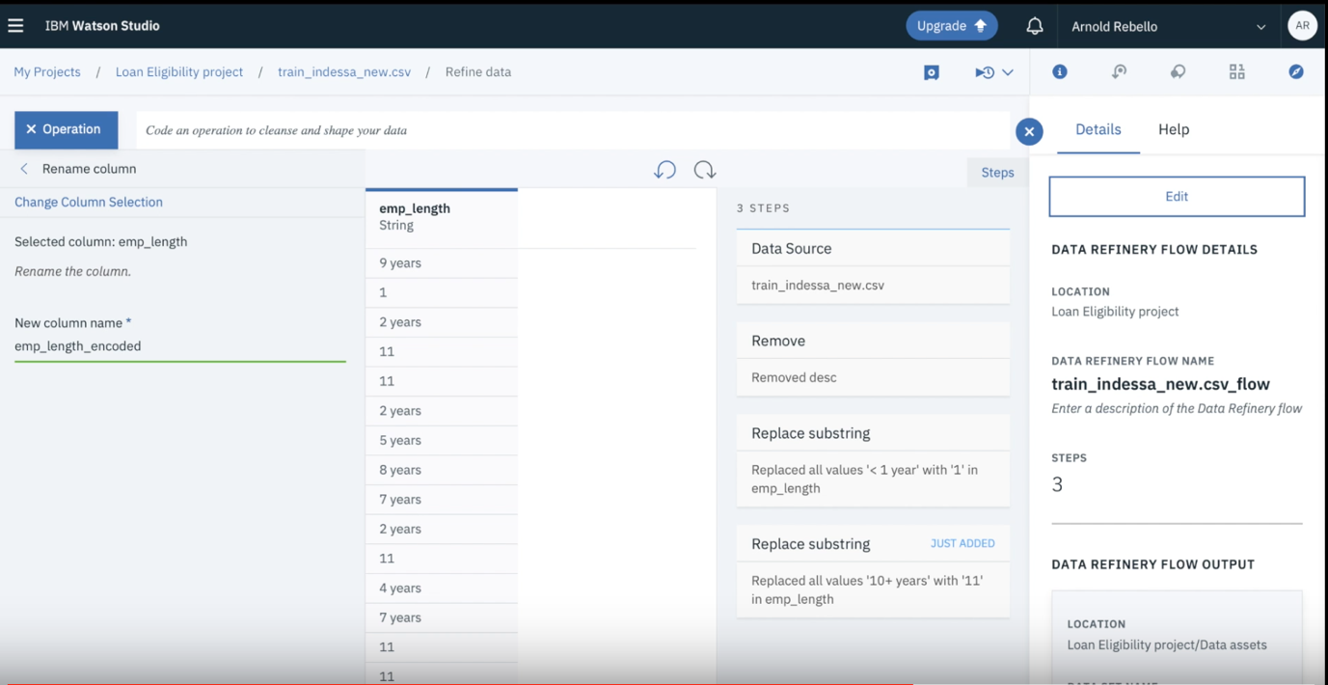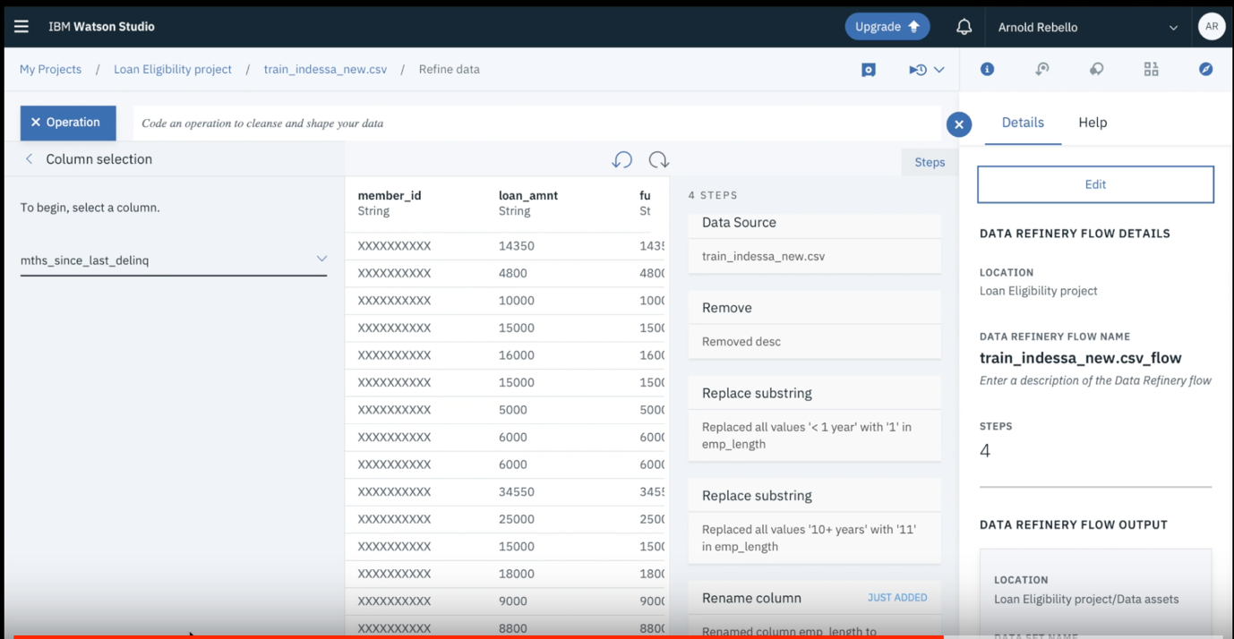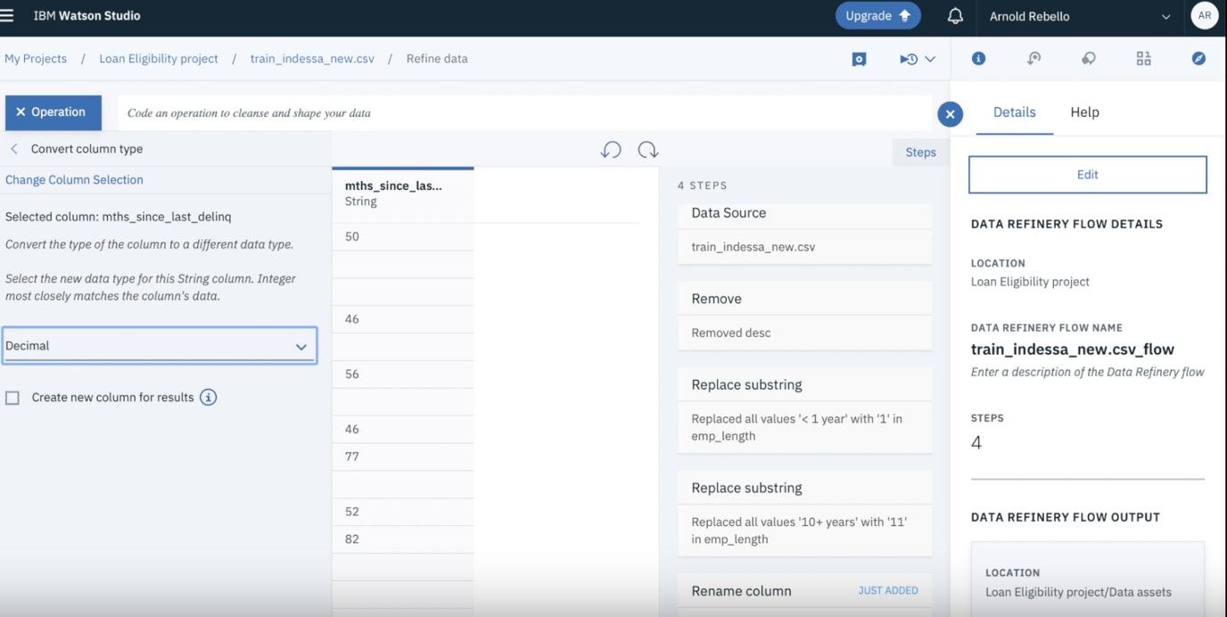

On the right hand side, you can see the logs of the steps performed by you in the past.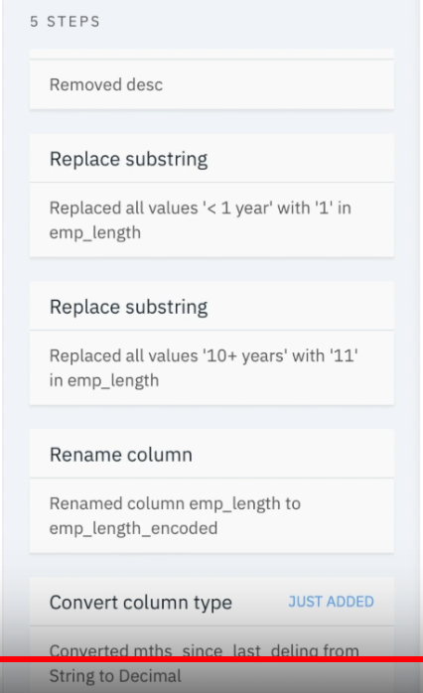

Last activity is to initiate a conditional replace. Under the operation section, Select the conditional replace and Select condition 1 as if mnths__since_last_dealing (column) is Empty (operator) then replace with 35.357

Click next and see the changes.

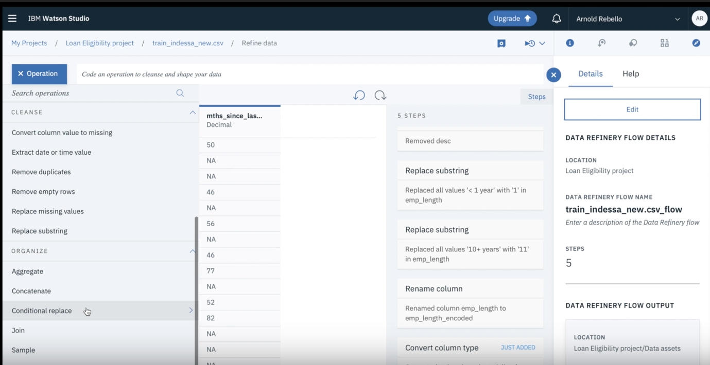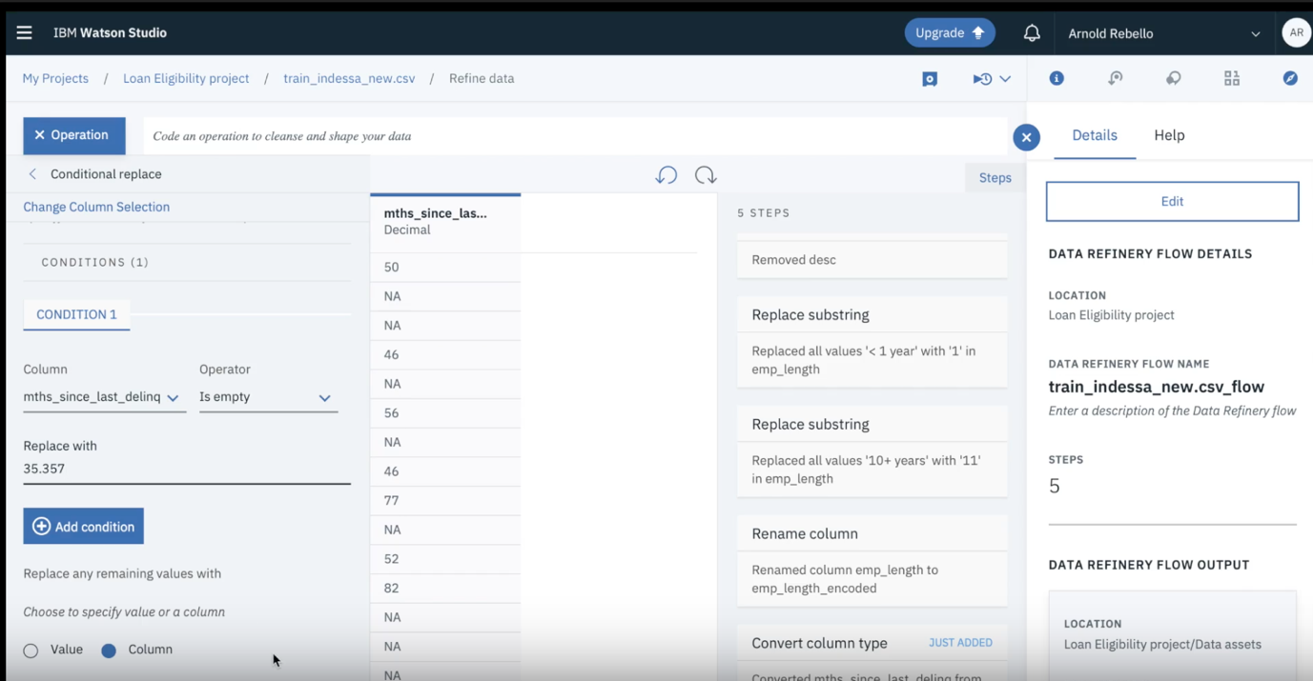

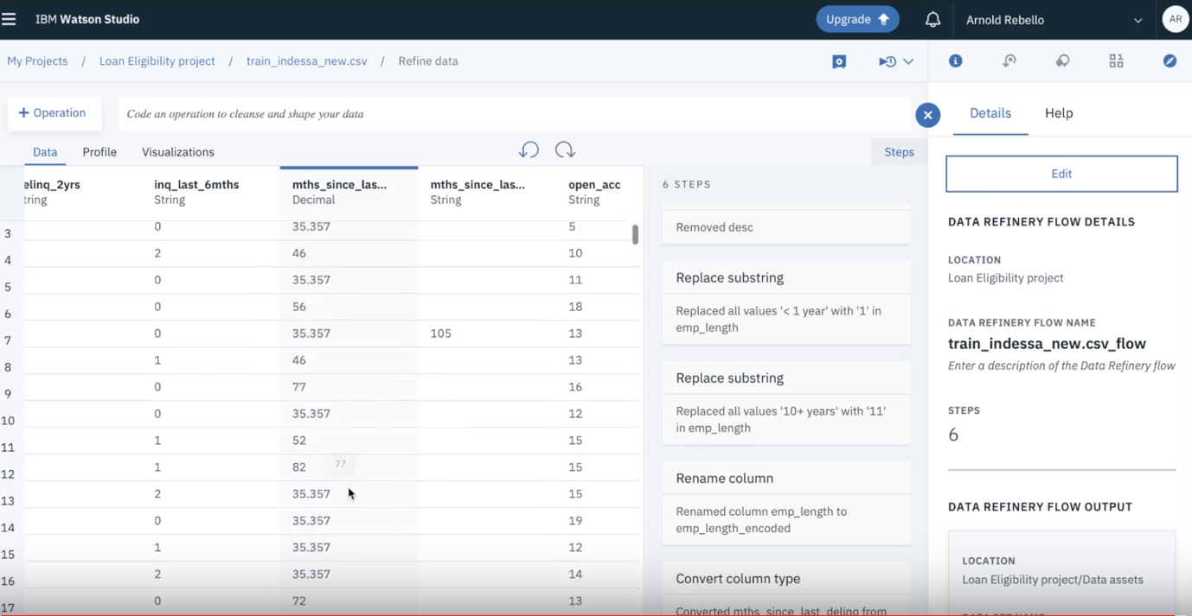

After completing this exercise, we are able to understand the process to perform the changes in the data set. This lab should not take more than 10 minutes.